King Hussein cared for country, people

The Times-Delphic, February 12, 1999
Guest Opinion
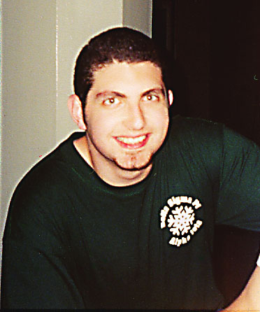
Wajih Halawa
Being the only undergraduate Jordanian on Drake's campus, I can see how many could not fully comprehend why I stayed up all night watching the funeral of His Majesty the late King Hussein. Why was he so special to these people? Monarchies today are seen as being ceremonial regimes where the ruler has limited power, if any at all. Kings and queens in some countries are seen hence as no more than national representatives.
Jordan is an exception. King Hussein was a hands-on ruler throughout his life, and his attention to the needs of his people was a major contributor to his popularity. He randomly appeared, unannounced, at public functions and often visited areas in the country that were in need of development to see what could be done to improve the quality of life. He would visit bedouins and sit with them in their tents, sipping coffee and chatting with them as if he was another member of the household, not a guest of international acclaim. He drove his own cars - even raced them with other professional drivers - and piloted his own airplanes, helicopters and boats, rather than being driven by others. His humility became the stuff of legends; I have heard from many acquaintances knowledgeable in royal affairs that, in his youth, King Hussein often disguised himself as a common civilian and toured the capital city of Amman. He rode public transportation, shopped in traditional markets and socialized with common Jordanians in an attempt to find out how the layman in the street felt about state affairs with all the filters and hindrances of protocol removed. Elderly women have told stories of how they quenched the thirst of a lone, young stranger who knocked on their doors asking for water, only to realize later that the king had been their guest.
During many public functions, I have seen various citizens from all walks of life yelling "Help!" to His Majesty. Rather than ignore them or turn them away, as his aides often tried to do, King Hussein would enthusiastically beckon them to approach, listening attentively to cases ranging from medical mishaps to educational difficulties. Every now and then, the king would surprise everyone by calling [TV and radio] shows and taking [problems] into his hands over the air, sending children abroad for treatment at his own expense or finding jobs for qualified people who had been plagued by ill luck.
Almost two years ago, King Hussein made a surprise visit to Jordanian television and interrupted the evening news on his way back from yet another unannounced visit to a state orphanage. Before the whole nation, His Majesty explained how he had been taken aback by the horrendous conditions the orphans had been living in and expressed his disappointment in the government's lack of responsibility and attention to these matters. Though always a calm man, he said he almost lost his temper several times as he saw cockroaches crawling across kitchen ceilings and infants without proper clothing or food. And as a result he decided to move out of his very own palace to a small villa (known today as Bab El-Salaam, "The Door of Peace"). The 150 children from the orphanage were immediately moved into the palace, with all its royal furnishings and servants, and they remain there until this day.
For all this, and much more, the people of Jordan wept as they heard the inevitable news. Even the skies let go of their load and watered the parched land, as if all the heavens were weeping with Jordanians, consoling them, comforting them, assuring them that those whom you cry for have planted seeds for a more fruitful future. Even if today is rainy with tears, tomorrow will surely be plentiful in the harvest, and the light hint of salt in your fruit will attest to the toil of its planter.
Goodbye, King of Hearts, King of Peace, King Hussein. The Earth is a better place because you dwelt upon it.

Wajih Halawa (BA3) is an information systems and finance double major and Times-Delphic photo editor.

